**SSFC Imaging Protocol**

Updated 2019/05/22

**Start Up Protocol**

1. Turn on Prior Lamp
2. Turn on Aurora Laser launch
   1. Flip main power on
   2. Turn laser key to on
   3. Flip shutter into open
3. Turn on computer breakers (on the rack under the keyboard)
4. Turn on computer
5. Put plunger with Amicii Prism in on the Bruker hardware segment
6. Open Prairie View Software
7. Double Right click scan settings
8. Write down current Camera and Scope Piezo Settings peak to peak voltage
9. Change Camera and Scope Piezo Settings peak to peak voltage to 0
10. Press Update Scan Settings

**Calibration Protocol**

1. Place a diffuse target in the sample holder
2. Go to Scope Settings
   1. Set the Emission Filter to Open
   2. Check that a pinhole aperture is being used
3. Assign the viewing window to Channel 1
4. Assign the 488nm laser to Channel 1
5. Increase the 488nm laser power till you can see lines
6. Capture a single image and title it 488nm
7. Zero the 488nm laser
8. Remove the 488nm laser Channel 1 assignment
9. Assign the 561nm laser to Channel 1
10. Increase the 561nm laser power till you can see lines
11. Capture a single image and title it 561nm
12. Zero the 561nm laser
13. Remove the 561nm laser Channel 1 assignment
14. Assign the 640nm laser to Channel 1
15. Increase the 640nm laser power till you can see lines
16. Capture a single image and title it 640nm
17. Zero the 640nm laser
18. Remove the 640nm laser Channel 1 assignment

**Acquisition Protocol – Single Images**

1. Double right click on the terminal
   1. This will let you input commands
2. Input Commands (SS needs to be upper case):
   1. SS 0 0 0
   2. SS -1.69 .2113 16
3. Do the Calibration Protocol
4. Assign all lasers that will be used into Channel 1 in the Lasers Window
5. Make sure empty Image Windows do not have a channel assigned
6. Slides need to be placed with coverslip face down
7. In the main window T-series tab
   1. Check the box for max speed.
   2. Set # of Reps to 16
8. Set Save Path
9. Press Start T-Series

**Acquisition Protocol – Image Stack**

1. In the main window Stage Control
   1. Go to the first xyz position
   2. Set xyz step sizes
   3. Open the SSFC_position_file_generator.m script in Matlab
   4. Set a unique identifying file name in the Matlab script
   5. Enter starting position and step sizes into the Matlab script
   6. Count how many steps you want to take in x, y, and z respectively and enter that number into the Matlab script
   7. Run SSFC_position_file_generator.m in Matlab
   8. Return to the PrairiView Main window Stage Control
   9. Select Import locations and import the file you generated with the Matlab script
2. Double right click on the terminal
   1. This will let you input commands
3. Input Commands (SS needs to be upper case):
   1. SS 0 0 0
   2. SS -1.69 .2113 16
4. Do the Calibration Protocol
5. Assign all lasers that will be used into Channel 1 in the Lasers Window
6. Make sure empty Image Windows do not have a channel assigned
7. Slides need to be placed with coverslip face down
8. In the main window T-series tab
   1. Check the box for max speed.
   2. Set # of Reps to 16
   3. Check the box Run at all XYZ Locations
9. Set Save Path
10. Press Start T-Series

**Acquisition Protocol – Single Position Video**

1. Double right click on the terminal
   1. This will let you input commands
2. Input Commands (SS needs to be upper case):
   1. SS 0 0 0
   2. SS -1.69 .2113 16
3. Do the Calibration Protocol
4. Assign all lasers that will be used into Channel 1 in the Lasers Window
5. Make sure empty Image Windows do not have a channel assigned
6. Slides need to be placed with coverslip face down
7. In the main window T-series tab
   1. Check the box for max speed.
   2. Set # of Reps to 16
8. Configure T-Series Settings (Wrench bottom left of window)
   1. Select Execution Order:

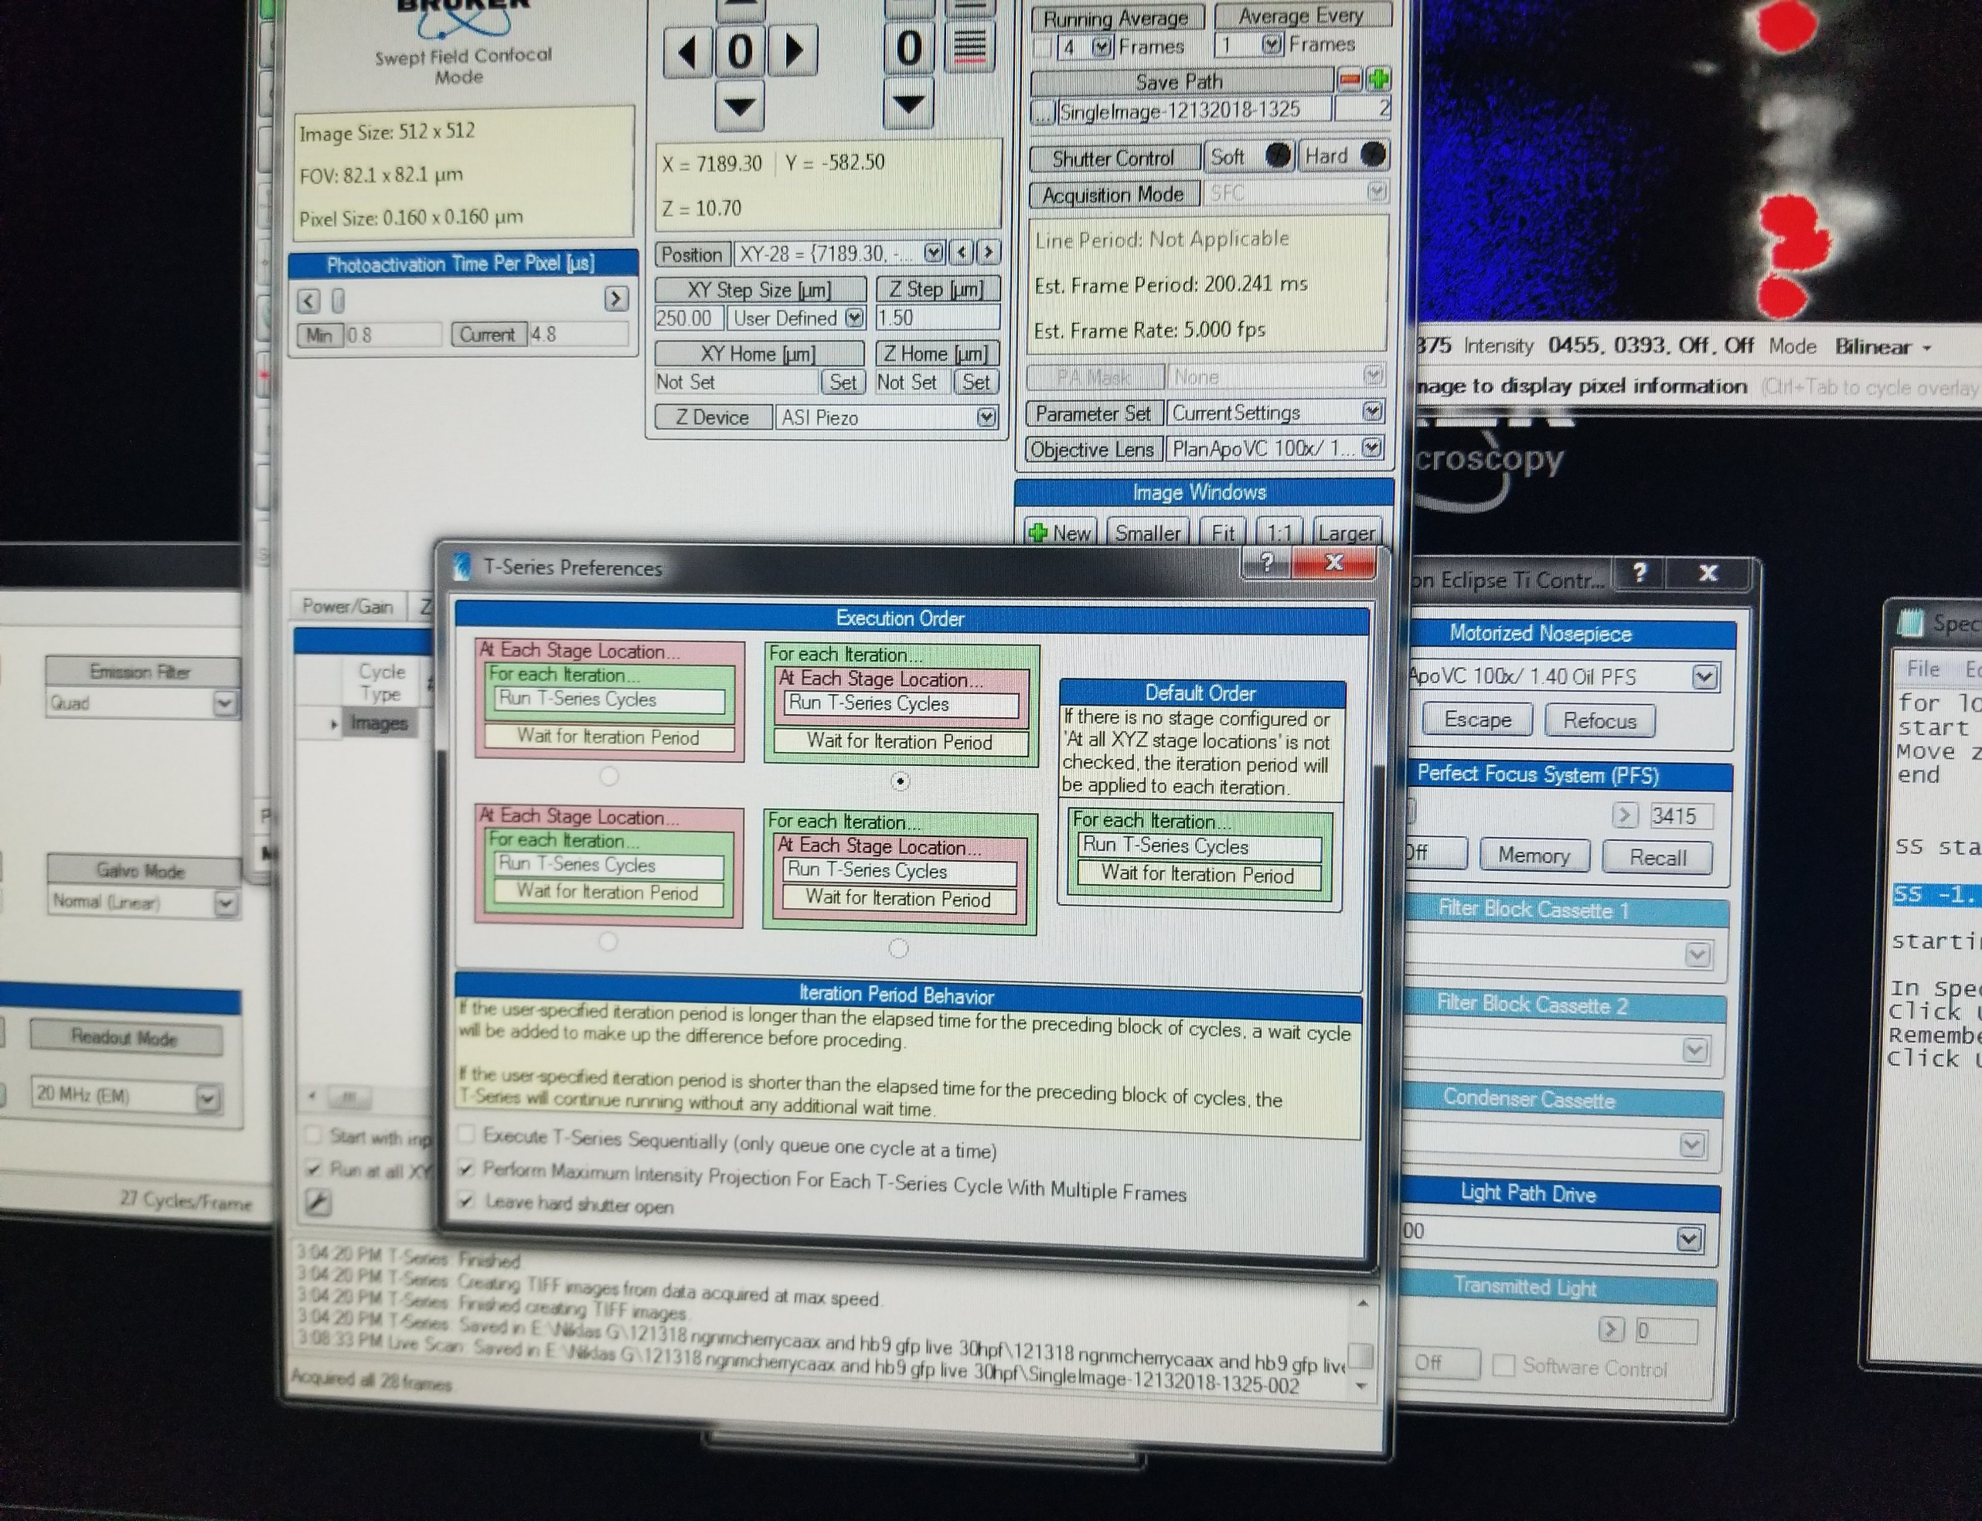

1. Set Number of Iterations
2. Set Save Path
3. Press Start T-Series

**Powering Down Protocol**

1. Copy acquired data to a back-up
2. Remove slide
3. If an oil objective was used clean the slide and objective carefully
4. Pull out Amicii prism plunger
5. Double Right click scan settings
6. Reset Camera Piezo Settings peak to peak voltage to original value
7. Press Update Scan Settings
8. Perform Pollen Grain Test
   1. Settings:
      1. 10x objective
      2. EM gain 200
      3. 50ms exposure
      4. 60 um pinhole
      5. LUT = full range
      6. Quad filter
   2. Procedure
      1. Find the highest intensity point of the pollen grains
      2. Move laser power slider until you have only a few pixels of saturation
      3. Record the laser power on the sheet
9. Turn off Aurora Laser Launch
   1. Flip shutter into closed
   2. Turn laser key to off
   3. Flip main power switch off
10. Turn off Prior Lamp
11. Turn off computer
12. Turn off computer breakers (on the rack under the keyboard)